Caching in RESTful APIs

🟦 WHAT
Caching is the process of storing a copy of data so future requests for that data can be served faster without reprocessing or fetching it again.

🟦 WHY
- ⏱️ Improves performance: Reduces server processing and network latency.
- 🔁 Reduces server load: Fewer calls to databases or external services.
- 🌐 Enhances scalability: Supports more users with less infrastructure.
- 💸 Saves cost: Less computation and bandwidth usage.

🟦 TYPES (Caching Strategies)
Strategy | Description
🔹 Client-side caching | Browser caches response using HTTP headers (Cache-Control, ETag, etc.)
🔹 Server-side caching | Server caches processed data in memory (e.g., Redis, in-memory object)
🔹 Reverse proxy caching | Middle-layer cache like NGINX or CDN holds content
🔹 Application-level caching | Cache specific function outputs or data in the app layer

🟦 MECHANISMS (HTTP Caching Basics)

🔹 Cache-Control Header (RFC 7234 - Official)
Cache-Control: public, max-age=3600, must-revalidate
Directive | Meaning
public | Cacheable by browsers and intermediaries
private | Only cacheable by the client
no-cache | Can be stored but must revalidate
no-store | Don’t store in cache at all
max-age=seconds | How long to consider response fresh
must-revalidate | Must check server if cache is stale

🔹 ETag and If-None-Match
Allows conditional requests — the server sends a short token (ETag), and the client checks freshness.
ETag: "abc123"
If-None-Match: "abc123"
If matched, server responds with 304 Not Modified.

🟦 HOW (Implementation in Express with Best Practices)

✅ Step 1: Set Cache-Control Headers (Client-side caching)
app.get('/api/products', (req, res) => {
res.set('Cache-Control', 'public, max-age=3600'); // 1 hour
res.json({ data: 'Product list' });
});

✅ Step 2: ETag Support (Built-in in Express)
Express generates ETags automatically unless disabled.
const express = require('express');
const app = express();
app.set('etag', 'weak'); // default, can be 'strong'

app.get('/api/item/:id', (req, res) => {
const item = { id: req.params.id, name: 'Item A' };
res.json(item); // ETag generated
});
Client will send:
If-None-Match: "generated-etag"
If matched, Express responds with:
HTTP 304 Not Modified

✅ Step 3: In-Memory Caching (Server-side caching)
For small-scale usage or dev mode.
const cache = new Map();

app.get('/api/data', (req, res) => {
const cachedData = cache.get('data');
if (cachedData) {
return res.json(cachedData);
}

const data = { time: new Date() }; // simulate real data
cache.set('data', data);
setTimeout(() => cache.delete('data'), 60000); // 1 min TTL

res.json(data);
});

✅ Step 4: Use Redis for Scalable Server-side Cache
Install Redis:
npm install redis
const redis = require('redis');
const client = redis.createClient();

app.get('/api/users', async (req, res) => {
client.get('users', async (err, data) => {
if (data) return res.json(JSON.parse(data));

const users = await fetchUsersFromDB();
client.setex('users', 3600, JSON.stringify(users));
res.json(users);
});
});

🟦 WHERE to Use Caching
Use Case | Recommendation
✅ Read-heavy endpoints | Cache results (product listings, blog posts)
✅ Static assets (HTML/CSS/JS) | Use long max-age and versioning
❌ User-specific/private data | Use private, no-store or disable cache
⚠️ Rapidly changing data | Use short max-age, or disable caching

🟦 UNIQUE SCENARIOS & BEST PRACTICES
Case | Recommendation
🌐 CDNs/Reverse Proxies | Use public, max-age, and ETag
🔐 Auth-protected endpoints | Use private, no-store
⏱️ Frequently changing public data | Use low max-age, or must-revalidate
📦 Paginated API results | Cache each page separately (/products?page=2)

🟩 Summary
Concept | Client-side | Server-side
Primary Mechanism | HTTP Headers | Code / Libraries
Speed | Faster for client | Faster for backend
Control | Limited | Full control
Use Cases | Static data, public APIs | Expensive DB queries

🟨 References
- RFC 7234 - HTTP/1.1 Caching
- MDN - Cache-Control
- MDN - ETag
- Express - response.set()

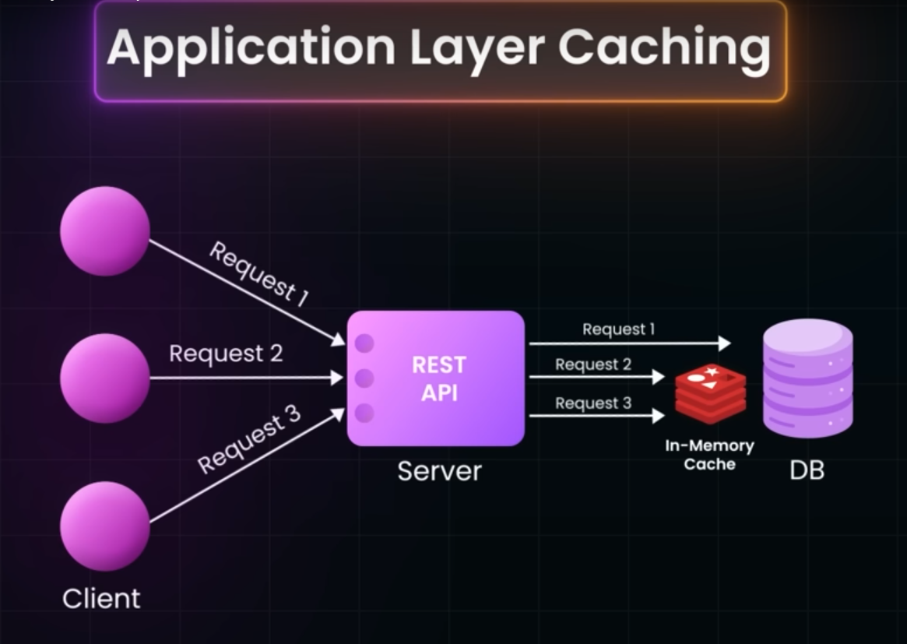

Cache Hit

Etag

Last Modified

